ULTIBOARD 12 (PCB. Design) 2015

Preparation at SCH. level.

Starting with a SCHEMATIC in MULTISIM ;

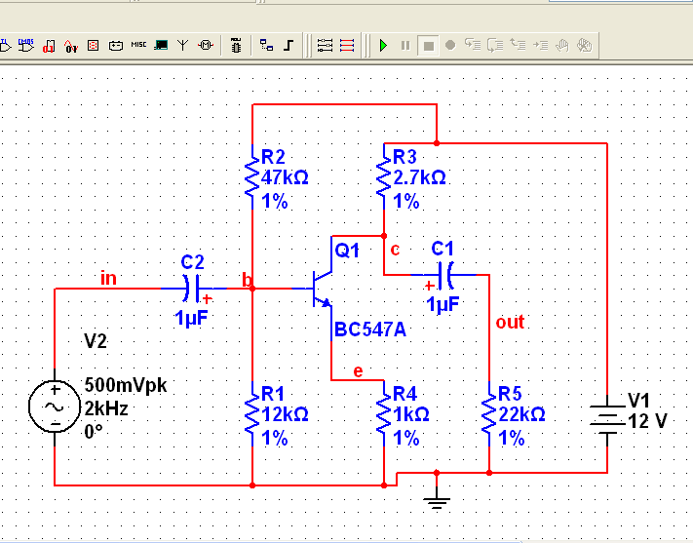

Construct and test (SIMULATE) this simple circuit; then use it to try a PCB design. (Board 50mm X 50mm).

Select each component (NOT voltage supplies) and click on EDIT FOOTPRINT;
(NOTE, schematic symbol turns from black to blue (indicating presence of footprint).

The first time you use a new component;
Select from MASTER Database; (Short list on next page).
Then IMEDIATELY click on COPY TO, and put into your USER Database.
Then click SELECT (lots of OKs to click for this stuff).

Then use the USER Database. for repeat components. (This is much faster the using the MASTER Database every time you need another resistor etc.).

SHORT CUT!! Select one resistor; rotate 90deg. Counter CW; EDIT FOOTPRINT, RES10. Then simply copy and paste as required ( even onto new sheets ). Also use this technique for other components.

LIST of useful FOOTPRINTS ( from MASTER Database)

Transistors THT (or TH ) {Through Hole Technology}
Small BC546 to BC550; BC556 to BC560; BC337 and BC327.
Power TIP121/2/6/7 and TIP41/42
TO-220;
(TO-92R;. Good Pin mapping for small devices BUT,
Pads are very close together, problems with hand soldering!!).
Transistors SMT ( or SM );{Surface Mount Technology} BC846 and BC856.

Resistor (250mW),
RES10 (TH); Surface mount, RES1206; 0402(very small)

Capacitor (Small to medium; Radial),
CAP1 (TH); Surface mount, C1206; 0402

Also see CAPPA, “Axial” and CAPPR, “Radial”

OP-AMPS,
DIP8; ( SM use SOT 8 )

Pots (Var.R)
POT0;
(modify exact pad position in PCB, eg. Change Y co-ordinate by 200mil)

Test Point Connectors library; TP1 is TH and TP2 is SM. (or add in PCB mode)

Dip Sockets
Select the sockets library.

NOTE; it may be necessary to “MAP PINS” so that Symbol Pins and Footprint pins are matched.

To Create NEW Footprint;

While in Ultiboard; Menu; Tools; Part Wizard

Select from THT or SMT, then click on “NEXT”

Think about pad numbers etc. “NEXT” to move on.

“Finish”; Save to Database; User Database; ( include name for footprint ).

PCB Layout. (From SCH.)

Menu; TRANSFER; Transfer to Ultiboard 12. ( ONLY at start!! )

NOTE; it is very important to know your units:

ALSO; For Digital circuits with DIP14s etc. add a 100n CAP in SCH, with VCC and DGND terminals attached; this will ensure that all pins 14 and 7 will be connected in PCB.

1mm = 39mil; 100mil = 2.54mm (approx.)

Select units (mm or mil) and put in Sensible “WIDTH” referring to track width.

(say, 20mil; OR 0.5mm; ).

OK all stuff to be transferred. The footprints will appear ABOVE the standard Eurocard (100mm X 160mm) PCB.

RIGHT click the yellow outline; then select PROPERTIES and enter required board size.

LEFT click “Window” to select all; then click’n’drag into PCB.

Use VIEW; ZOOM WINDOW to view components close up.

RIGHT click (or LEFT click window) to select each component (dashed yellow outline appears); then LEFT click to move, rotate etc.
( Ignore the brown strings; they are just some sort of position reference. )

NOTE; as much as possible, position components as in the SCHEMATIC. This will make hand assembly and test much easier.

ALSO, in the PCB file SM components can be moved to the BOTTOM of the board. They can then be moved as if they overlap SM components on the TOP; saving more space.

For changes or updates, work in SCH then use Forward Annotate in Menu Transfer.

BEFORE autorouting,

(NETS = copper tracks) (Menu; View; Spreadsheet, if not visible)

Copper Layers (double sided “11”)

Click on the “NETS” tab along the bottom of the screen; select “Routing Layers”.
The whole column turns blue, with 10 in each entry (1 for TOP layer “ON”; 0 for BOTTOM layer “OFF”).
Click the blue then select both TOP and BOTTOM, CHECK ALL and OK. All Net entries should read “11”.

Copper track width

Click on “Trace width”. Select any net and put in a number; then click and double click “Trace width”. This will change ALL nets to the new width (eg. 20mil or 0.5mm).
To set individually, say 40mil or 1mm for a thicker earth rail. Enter the number then click only once.

(THT pads = pads “blue rings”).

Diameter, drill hole etc. Click and select as before.

For standard components and DIPs; try

Drill Diameter = 30mil (0.75mm)
Pad Diameter = 70mil (1.75mm)

Use these for all pads, then individually modify for unusual components.
eg. Power device or connector with thick pins;
Drill Diameter 40mil ( 1mm); Pad Diameter 80mil ( 2mm).

Menu; AUTOROUTE; START/RESUME AUTOROUTER.

ALL the thin yellow nets should be converted to green and red copper tracking. ALSO, some MANUAL tidy-up necessary for a tidy PCB.

Menu; EDIT; Copper Delete; All Copper. Or UNDO to reverse Autorouting if change is required. Then go back to “BEFORE autorouting”.

Menu; Place; Graphic; Text. This allows you to put name etc. onto board.
(NOTE, select COPPER TOP above your PCB first)

